Hanging Requirements for Artworks
Hangings must have a good solid frame and must have hangers on the back strong enough to support the weight of the artwork.
Photos of eyelets to be used.
The suggested hardware makes it possible for the CVAA Hanging Committee to hook them onto the pre-existing hanging system installed at the gallery as shown.
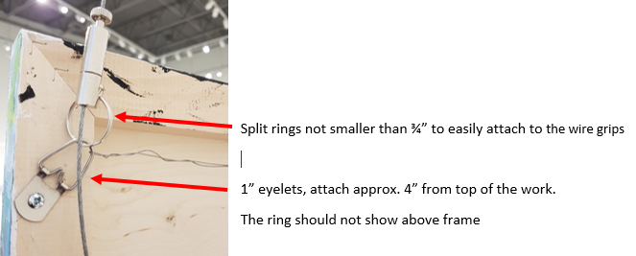
Exception occurs with textile pieces, wall hangings or 3D pieces.
For security reasons and to assist with correct labeling of pieces please attach a label on the back of your piece (also on 3D pieces if at all possible).
Information on the label should read:
Your name:
Phone Number:
Title of Artwork:
Medium:
Size:
Price:

