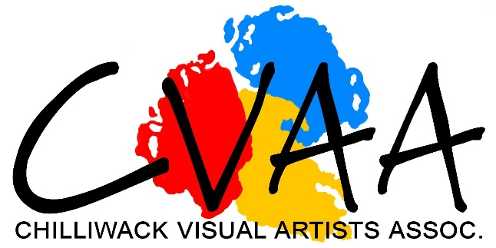
The Chilliwack Visual Artists Association invites visual artists in any medium to apply for consideration to exhibit in the O’Connor Group Art Gallery for years 2023 & 2024

An exhibition may be by a solo artist, partnered, or a group. Subject to approval, exhibition space will be allocated in the Chilliwack Art Gallery.
Overview of Competition
- A jury Committee will adjudicate all submissions.
- All submissions must be received no later than July 31st 2022.
- All artists will be informed of the jury’s decision on or before September 1st 2022.
- If accepted, a contract will be issued. Completed contracts along with fees need to be received by the CVAA no later than September 15th 2022.
- An exhibition schedule for 2023/2024 will be determined by the CVAA.
- All artwork chosen to exhibit must be ready for hanging. Specific hanging requirements will be available after acceptance by the jury.
- Criteria for judging will include, but will not necessarily be limited to: presentation, creativity, originality, technical skills, design and expression, and the completeness of the application.
- All work must be the artist’s own original creation.
- Artists who have previously been chosen to exhibit in the O’Connor Group Art Gallery during the years 2020/22 are discouraged from applying. Priority will be given to artists who have not exhibited within the last two years.
- The exhibition fee is: solo artist $120.00; double or triple show $160.00; a Group of four or more artists $300.00. Do not include any payment when submitting an application form. The appropriate exhibition fee must be enclosed when you return your completed contract.
- A 20% Commission on all sales will be charged by the CVAA.
- Applicable taxes are the responsibility of the individual artist.
- The CVAA is considering becoming a member of CARFAC, however at the moment of publishing this call this has not been decided yet.
- Below you will find a section: ‘About the O’Connor Art Gallery’, please read this carefully.

About the O’Connor Art Gallery

The O’Connor Art Gallery is located in the Chilliwack Cultural Centre and is managed by the Chilliwack Visual Artists Association (CVAA) which is a non-profit volunteer organization. The gallery has a dual function: it is an art gallery and also a rental space for the Cultural Centre. During the year there are several fundraising events organized by the Cultural Centre which require the use of the art gallery; thus vendors may be placed in the gallery. Food and drink may also be allowed in the gallery during this time. Some events are scheduled in advance and some rentals are requested with short notice. The Cultural Centre and the CVAA try to coordinate scheduling to be respectful of the artist’s needs; however, artists exhibiting in the O’Connor Gallery need to be aware of the dual function of the space. When the gallery does host an event several hundred people may pass through the gallery viewing the art on display. This does provide the artist with additional exposure. If artists have any concerns, they should make this known at the time of scheduling and every effort will be made to accommodate their needs.

APPLICATION FORM
PLEASE PRINT
Artist’s Name, (for groups, the FIRST name will be the contact person)
________________________________________________________________________________
________________________________________________________________________________
________________________________________________________________________________
________________________________________________________________________________
Mailing Address _______________________________________ City ______________________
Postal Code _______________Home Phone _______________Business or Cell phone __________
Email:_____________________________________

CHECK LIST Application Form – Complete the application form below in full:
- 1. Artist’s Biography.
- 2. Artist’s statement, or the group’s mission statement.
- 3. Samples of recent artwork on a memory stick, jpg images (min 300 dpi) or PDF or good quality 5” x 7” photographic prints. Each photo should be labeled with the artist’s name and title.
- 4. An inventory list of titles, medium, and size should accompany the images.
If you wish to have your memory stick or prints returned, please include a self-stamped addressed envelope with appropriate postage.
Please check that you have addressed all 4 requirements.

Submit, before July 31st 2022.
Artists will be notified of the jury’s decision by September 1st 2022.
There is no cost for submitting, but there are exhibition fees (see overview)

Submission by mail: | Drop off in an envelope addressed to  CVAA, Call for Artists | By email
CVAA, Call for Artists  ATTN: Mary-Lee Merz  9201 Corbould Street  Chilliwack, BC V2P 4A6 | Cultural Centre Box Office  ATTN: Mary-Lee Merz  9201 Corbould Street  Chilliwack, BC V2P 4A6 | cvaa.gallerycoordinator@gmail.com
This document can be retrieved from the CVAA website www.chilliwackvisualartists.com or picked up from the O’Connor Group Art Gallery during gallery open hours. http://oconnorgroupartgallery.com/call-for-artists/
For more information contact Mary-Lee Merz at cvaa.gallerycoordinator@gmail.com

